**A000-Pac-Poly-Tahiti-Wallis on his arrival at O’Taheite-Print-1782**

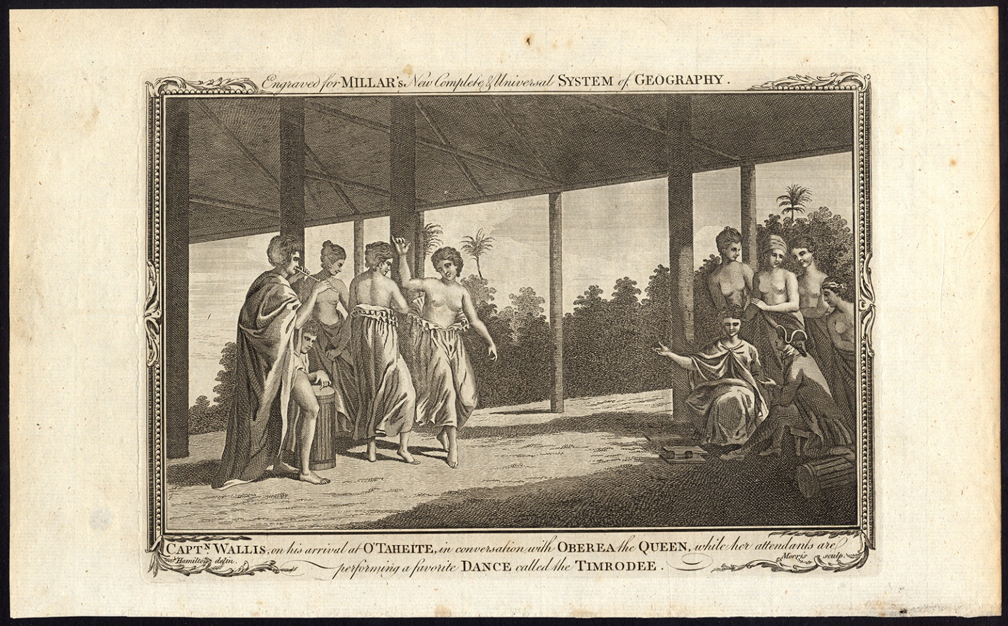

**Case no.:**

**Accession Number:**

**Formal Label: Pac-Poly-Tahiti-Captain Wallis on his arrival at O’Taheite, in conversation with Oberea, the Queen, while her attendants are performing a favorite Dance called the Timrodee.**

**Display Description: Engraved for Millar’s New, Complete & Universal System of Geography. Engraving by Morris after a drawing by Hamilton.** 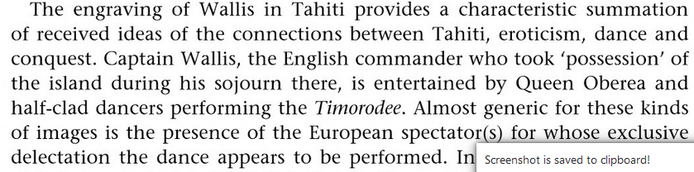

(Balme 2008: 41).

**LC Classification:** PN3030;GV1728 T33

**Date or Time Horizon:** 1782

**Geographical Area:** Tahiti

**Map: after https://upload.wikimedia.org/wikipedia/commons/thumb/0/06/Karta_FP_Societe_isl.PNG/390px-Karta_FP_Societe_isl.PNG**

|  |
| --- |
| [Karta FP Societe isl.PNG](https://en.wikipedia.org/wiki/File:Karta_FP_Societe_isl.PNG) |

**GPS coordinates:** [17°40′S 149°25′W](https://tools.wmflabs.org/geohack/geohack.php?pagename=Tahiti&params=17_40_S_149_25_W_type:isle_scale:250000_region:PF)

**Cultural Affiliation:** Polynesia

**Medium:** Paper

**Dimensions:**

**Weight:**

**Condition: original**

Provenance: [Millar, George Henry](https://archive.org/search.php?query=creator%3A%22Millar%2C+George+Henry%22) . 1782. The new and universal system of geography: being a complete history and description of the whole world, containing a particular, full, accurate, circumstantial, and entertaining account, including the antient and present state of all the various countries of Europe, Asia, Africa, and America, as divided into empires, kingdoms, states, republics, and colonies. London: Printed for Alex. Hogg.

**Discussion:**

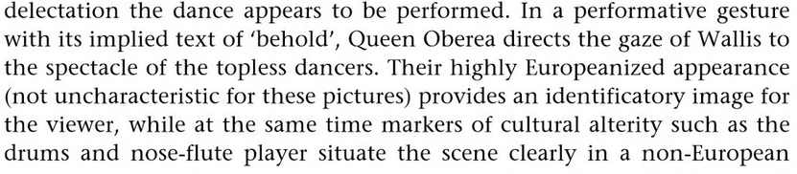 (Balme 2008: 41-42).

Samuel Wallis (23 April 1728 – 21 January 1795) was born near Camelford, Cornwall. He served under John Byron, and in 1766 was promoted to captain and was given the command of HMS *Dolphin* (1751) as part of an expedition led by Philip Carteret in the *Swallow* with an assignment to circumnavigate the globe (Quanchi, Max. 2005: 248). After the two ships were parted in a storm after navigating through the Strait of Magellan, Wallis continued to Tahiti, which he named in June 1767 "King George the Third's Island". Since Wallis was ill lieutenant Tobias Furneaux was the first to set foot on Tahiti from the *Dolphin*, and claimed possession of Tahiti in the name of His Majesty. Wallis named or renamed five more Society Islands, six atolls in the Tuamotu Islands, and Uvea (as Wallis after himself), before reaching Tinian in the Mariana Islands. Many of the crew died in Batavia from dysentery. From the Cape of Good Hope he sailed to England, arriving in May 1768. Captain James Cook who was to depart for the Pacific received valuable information from Wallis s well as some of the *Dolphin* crew (Quanchi, Max. 2005: 248). In 1780 Wallis was appointed Commissioner of the Admiralty.

**References:**

Balme, Christopher B. 2008. *Pacific Performances: Theatricality and Cross-Cultural Encounter in the South Seas.* Houndmills, Basingstoke; New York: Palgrave Macmillan.

Quanchi, Max. 2005. Historical Dictionary of the Discovery and Exploration of the Pacific Islands. New York: The Scarecrow Press.